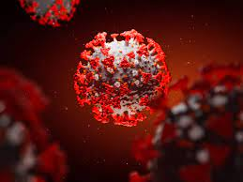
From the Series
God, His People, and the Pandemic
“Faith Vs Trust”
Scripture Reading: Hebrews 11:6; Proverbs 3:5-6

Today’s Focus: In order to please God, you must know the difference between faith and trust, and they both must be active in your relationship with Him

What is difference between Faith and Trust?

_____________ is demonstrated when your relationship with someone or something result in your complete belief in their capability and understanding of their probability to the degree that it leads to action.

______________ is using evidence or experience to evaluate the capability and probability of something or someone to determine and act on reasonable expectations.

Capability and Probability

Capability - the power or ability to do something. The extent of one’s ability.
- how much one can be there – availability - _______________
- how much power or influence one has – _______________
- how much knowledge and wisdom they have – ________________
- how consistent and reliability they are - _______________

Probability - the extent to which one’s actions are predictable; the likelihood of something happening or being the case.
- how fair, selfless, and unbiased they can be - ____________
- how much they can see your greater good - ____________
- how much your responsibility is irrelevant - ______________

Key Principles for Understanding Faith

- Faith is a tool that aligns the power of the Holy Spirit with our freewill surrender and connect be an act of “__________ _______________”. [1 Corinthians 2:4-5]
- Faith is the act of aligning with the ___________ of God’s wisdom outside of time and space. [1 Corinthians 2:6-7]
- Faith is incomprehensible outside of the work of the _________ [1 Corinthians 2:8-10]
- Faith cannot be measured by the principles of __________ and ________. [Luke 17:3-6]
- Faith has no significance without ___________. [James 2:26]

